Build NodeJS App using Jenkins.

1. In Plugin manager, Install **nodejs** plugin
2. Install npm (node package manager) and nvm (node version manager) on Jenkins Instance.

<https://docs.aws.amazon.com/sdk-for-javascript/v2/developer-guide/setting-up-node-on-ec2-instance.html>

curl -o- https://raw.githubusercontent.com/nvm-sh/nvm/v0.34.0/install.sh | bash

. ~/.nvm/nvm.sh

nvm install node

node -e "console.log('Running Node.js ' + process.version)"

1. Check for Version npm and nvm version. (In my case it’s showing 6.13.1)

npm version

node -v

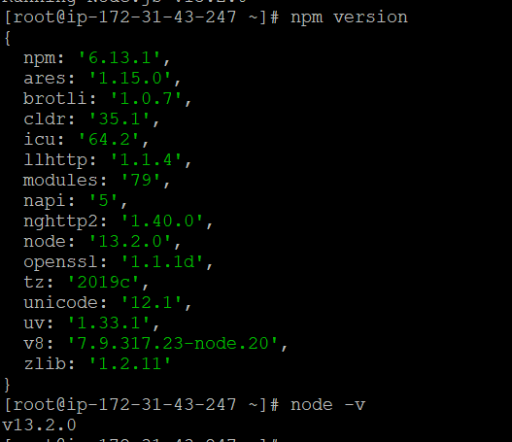

1. Configuring Node.js tool, go to jenkins’s home > Manage Jenkins > Global Tool Configuration. Search for NodeJS and click on NodeJS installation button.
2. create a freestyle job **build-test.**

**You can provide github source code url**

1. Under Build Environment, select option “Provide Node & npm bin/ folder to PATH”.Type “localnodejs” in NodeJS Installation section. Keep the remaining as it is.
2. Under **“Build”** section, Click on **“Add build step”** button and then click **“Execute shell”** option.In that, type **“npm install”** and then click on Save

8. Now, you can build the job.